Step 1: Selected Ubuntu Linux Installer 3.6 version

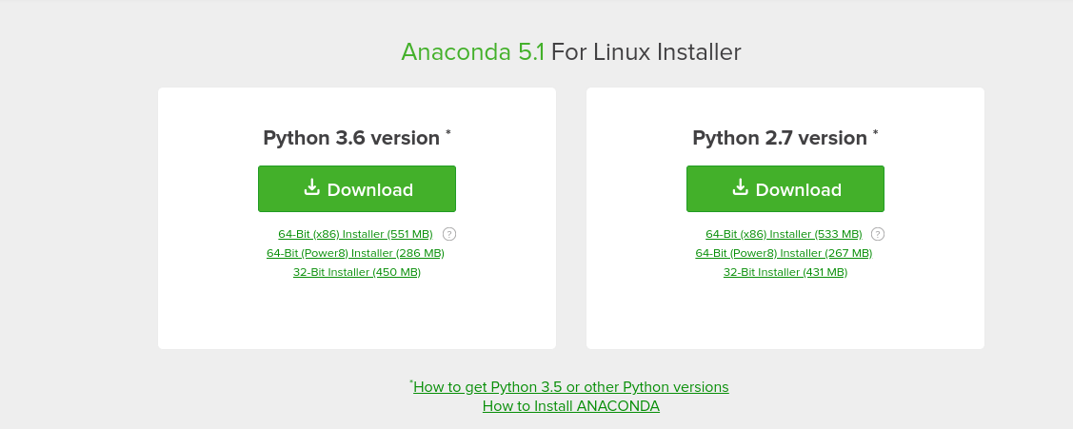

Step 2: After installing Anaconda ,open the anaconda prompt by typing anaconda prompt in the windows search tab and inside the prompt we need to type “ jupyter notebook “as shown in the below screenshot.

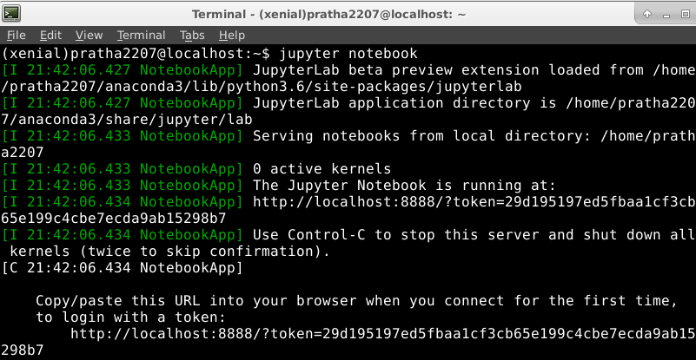

Step 3: Jupyter notebook will get open as soon as you enter the above command and notebook pops up as shown in the below screenshot.

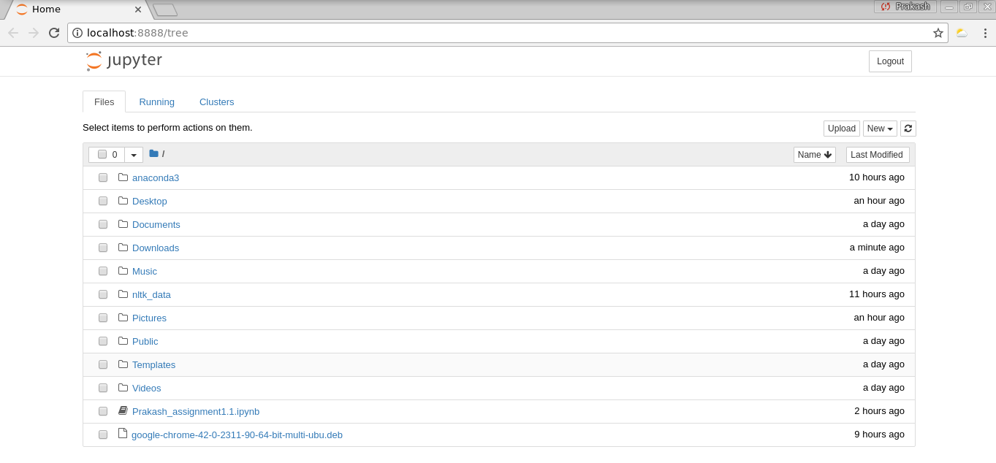

Step 4: On clicking the python 3 file we get a screen as shown below where we can type the

scripts and execute it.

